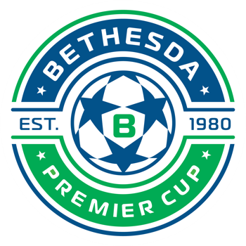

To Whom It May Concern:
Your school has a player(s) who will be participating in the Bethesda Premier Cup Soccer Tournament on Friday November 10th or Friday November 17th, 2023.

The Bethesda Premier Cup Tournament is a College Showcase event with many college coaches in attendance. This tournament offers players with the opportunity to continue their careers at the collegiate level, as well as possibly securing financial assistance to attend college.

We are offering this written documentation so that their absence from school will be excused and will not adversely affect their attendance status.
We thank you for supporting your student-athletes.

Yours in Soccer

B A Roos
Brad A. Roos
Tournament Director

